ECMS FE

- Login as Trader
- Go to ACT Registration and click on Create ACT Registration.
- Click on the add button available on the top right corner of the dashboard.
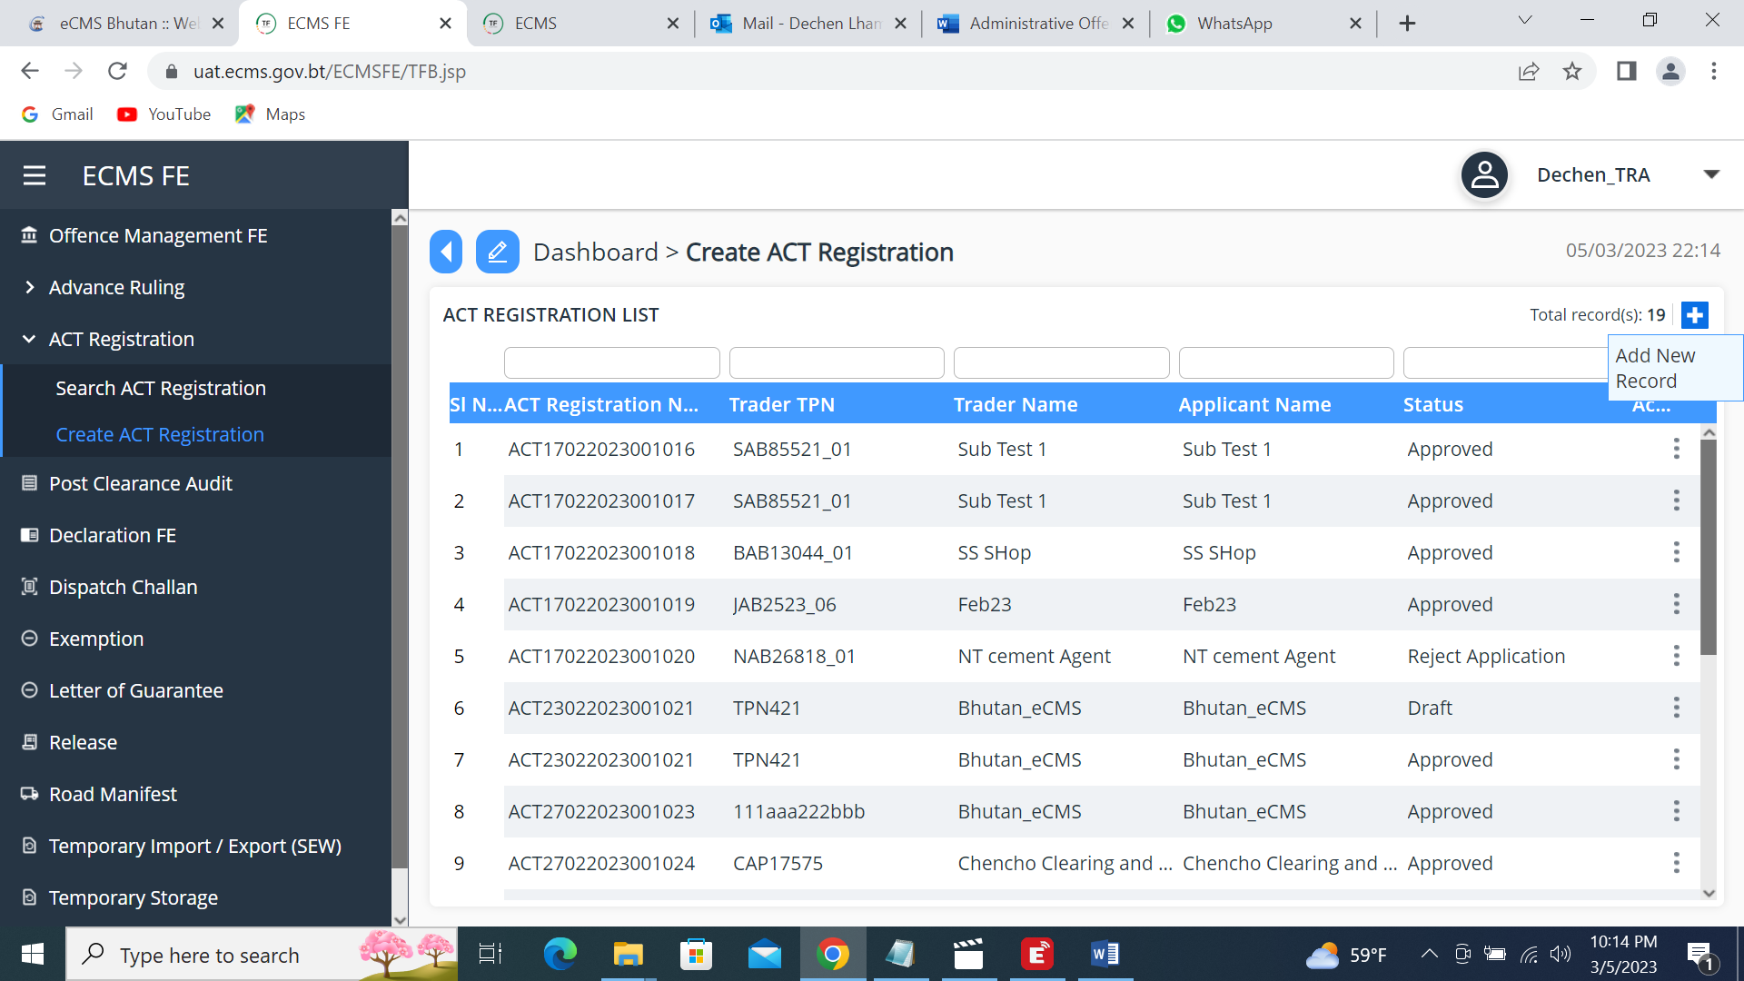
- ACT Details dashboard appears as shown below;
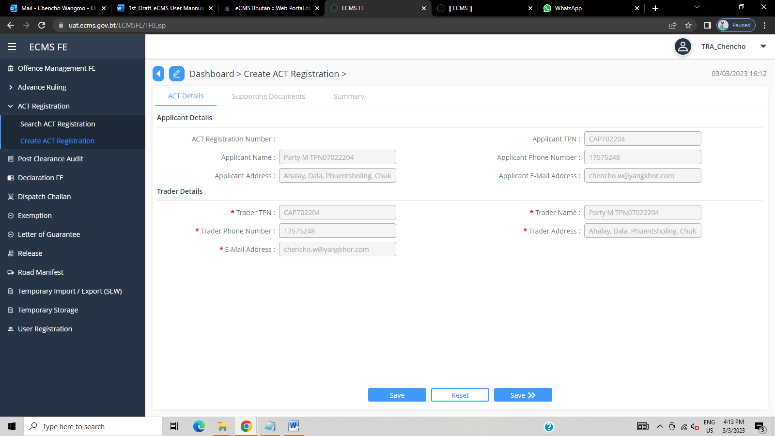
- Then click on Save>> button.

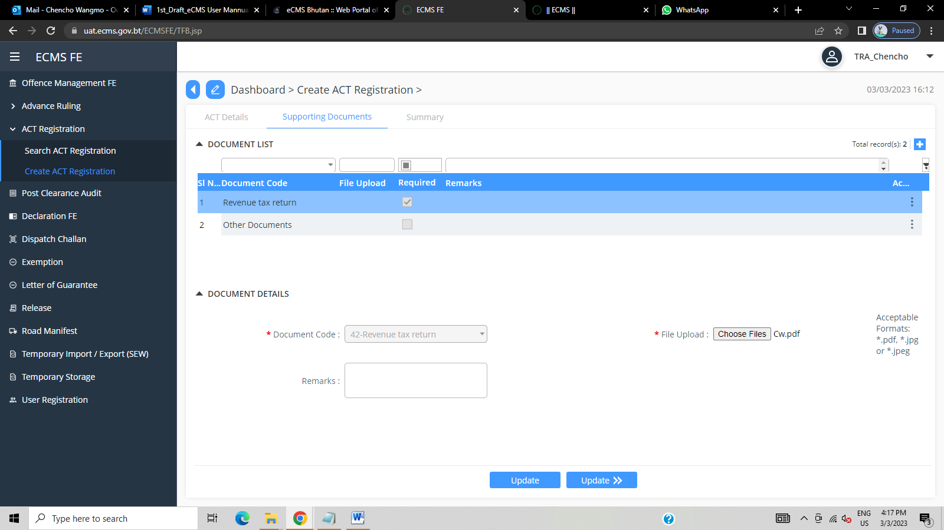
- Go to Supporting documents, upload file and click on Update>> button
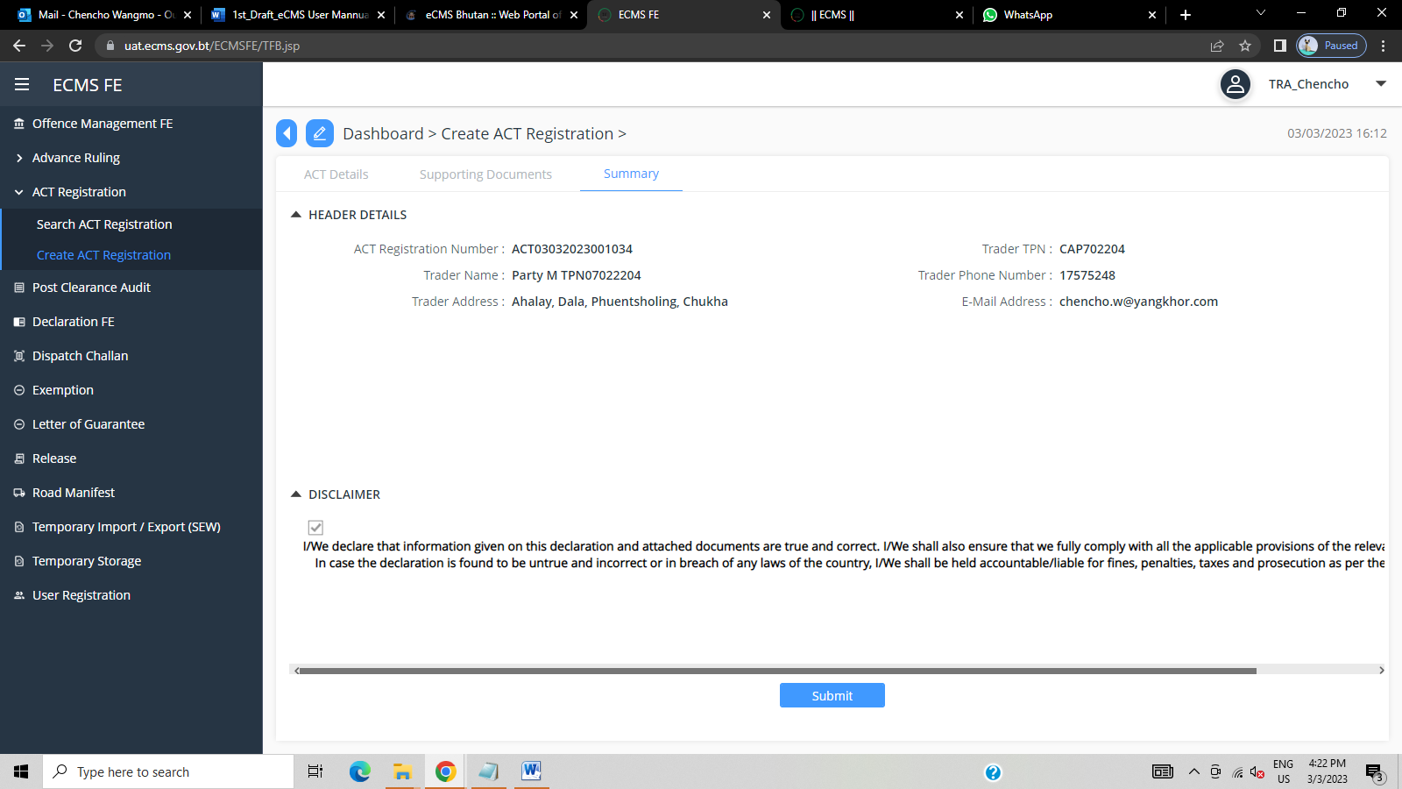
- Next go to summary and click Submit button, a successful ACT Registration number pops up.

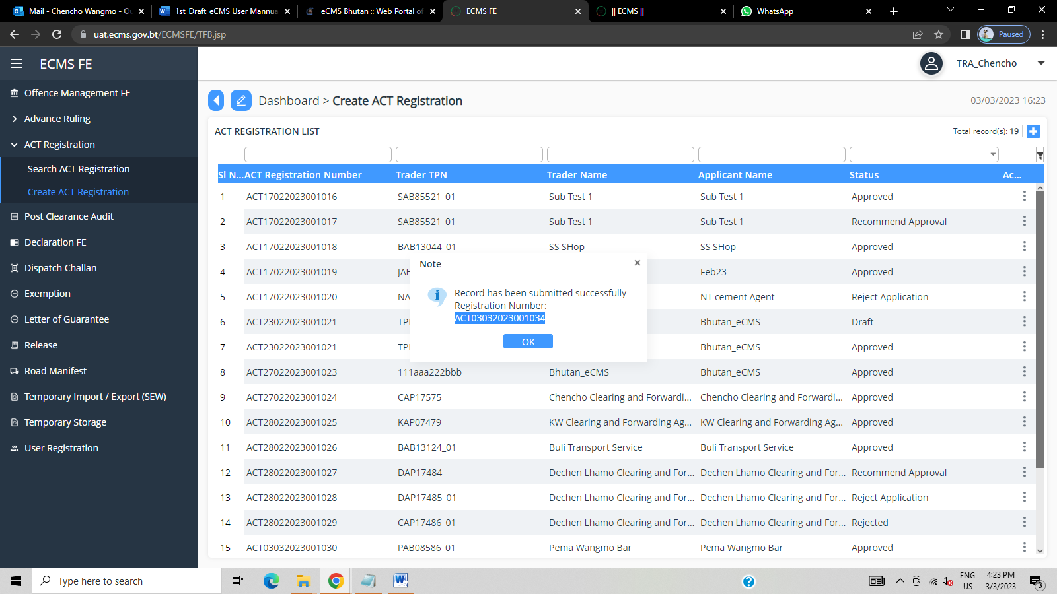
ECMS
- Log in to Custom
- Go to ACT Registration and click on Verifier.
- Paste the ACT registration number on the search panel.
- Go to Inspection checklist, tick on comply option and update.
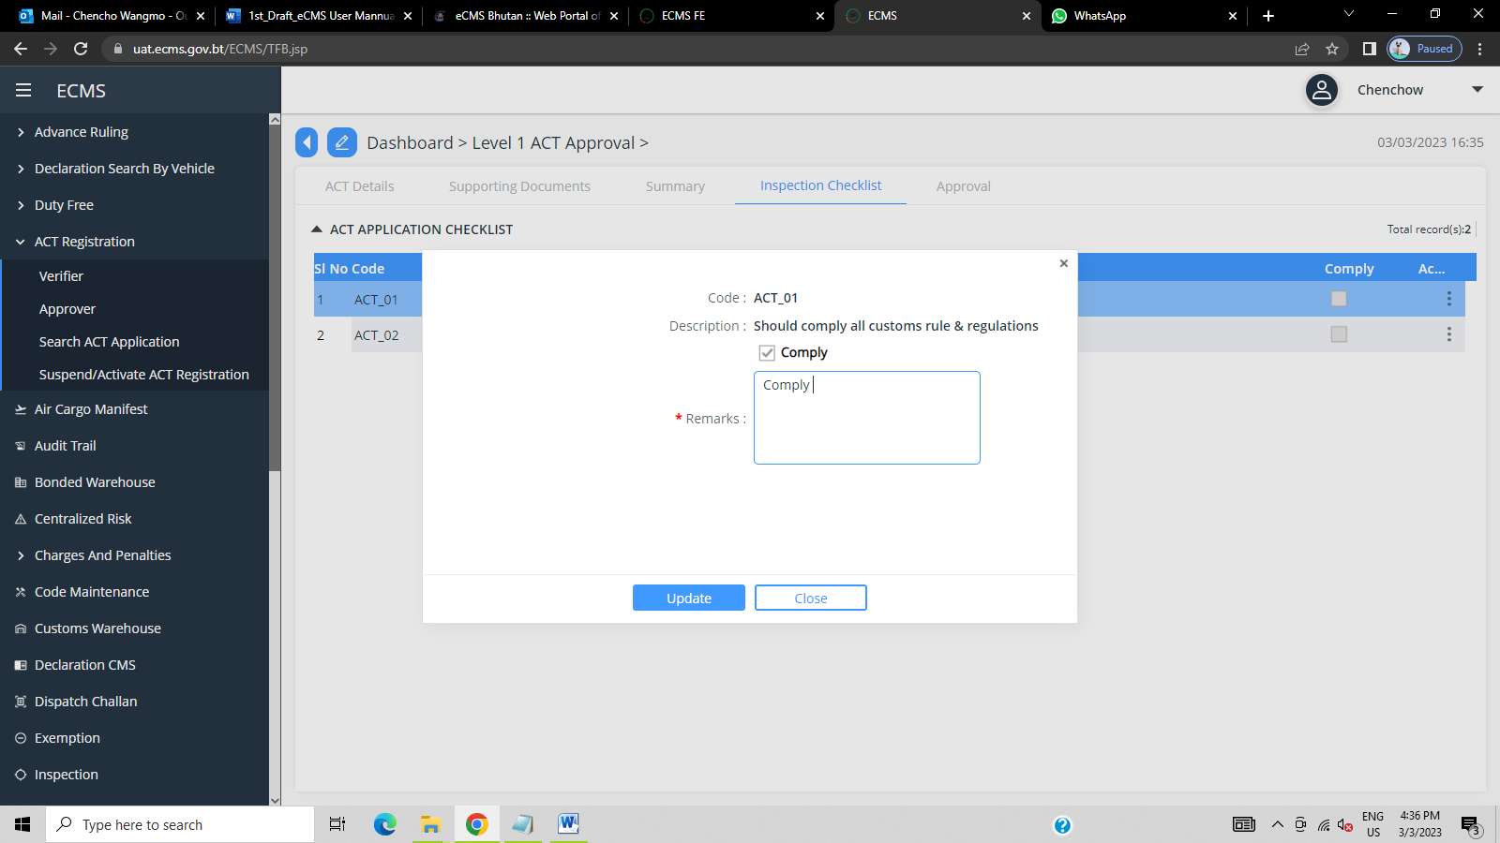
- Click Approval button and change the status as ‘Approved’.
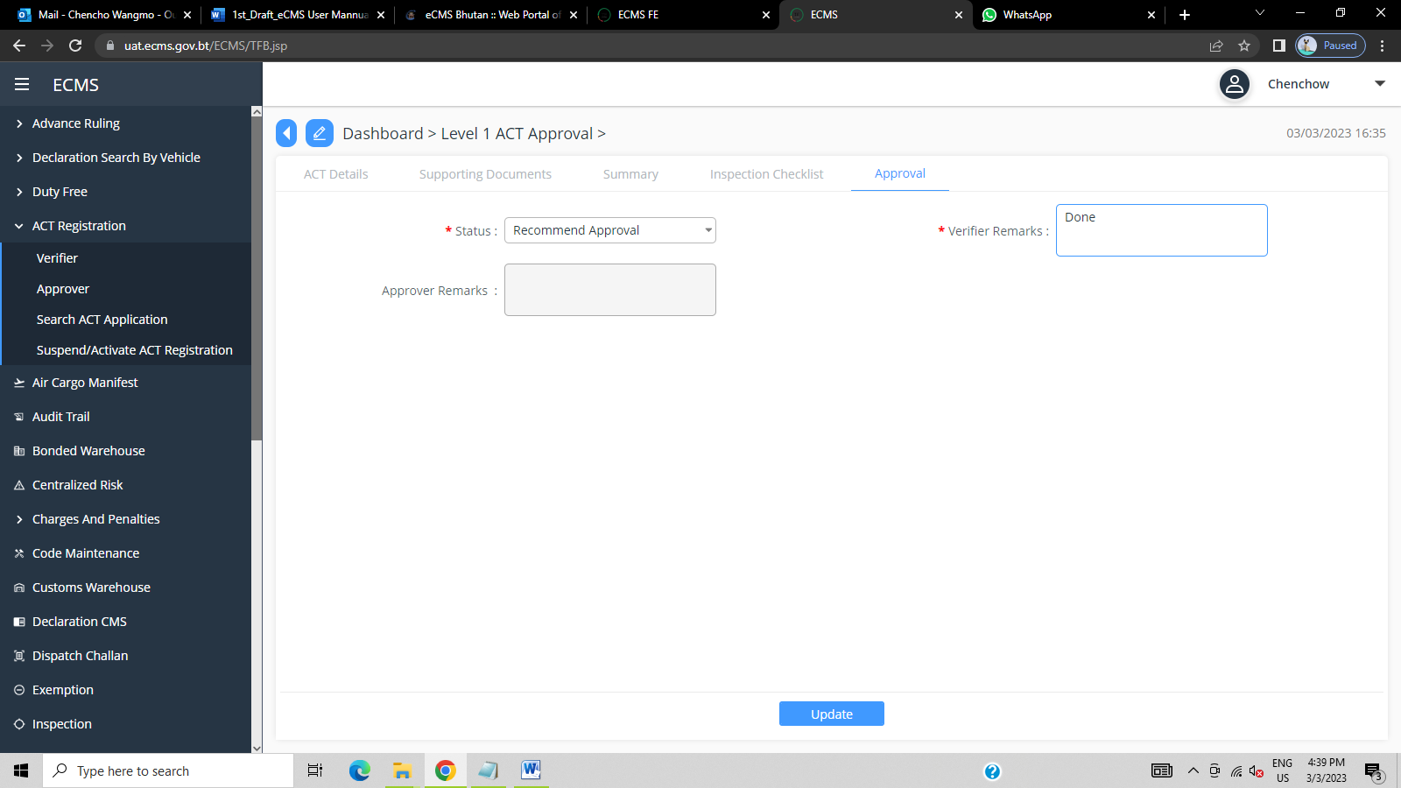

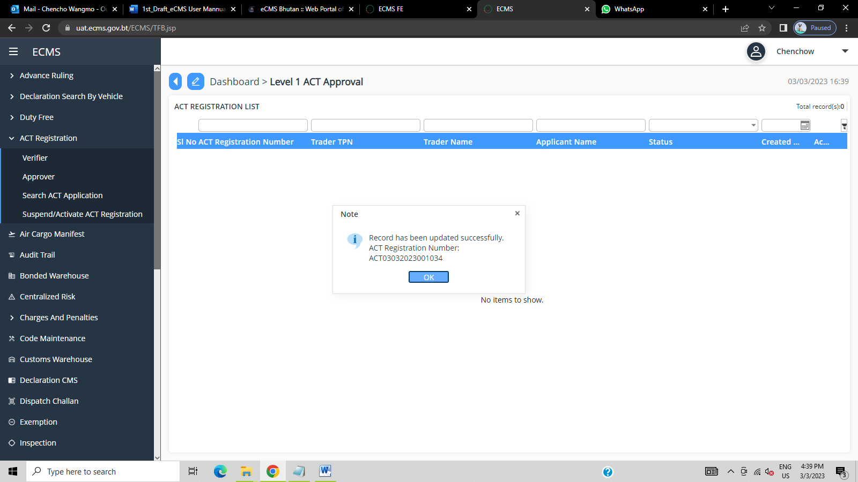
- ACT registration number will appear.

